YOUNG LEARNERS SUMMER SOCIAL PROGRAMME 2020

 | 27th July |  | 28th July | 29th July | 30th July | 31st July | 1st August | 2nd August
09.00  12.30 | Classes |  |  |  |  |  | Day trip to  London  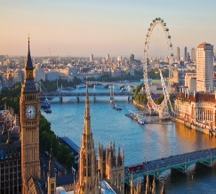  08.00 - Departure  18.00 – Arrival  Packed lunch provided  (by LTC for residential students, by families for homestay students)  Coaches arrive & depart  to / from LTC | 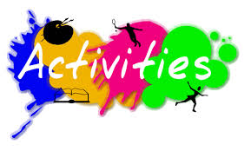  with Social Team  Supervised    
12.30 | Lunch
13.30-18.00 | New Students  Orientation Tour of Eastbourne  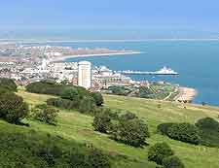 | Others –  (limited spaces, sign up only)  with Social Team | Classes 13:45-15:30  (Semi-Intensive only)    (limited spaces, sign up only)  Roller Skating    (limited spaces, sign up only)  with Social Team | Trip to  Battle Abbey  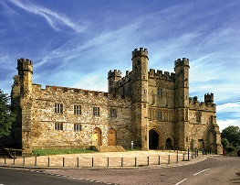  13.30 – Departure  18.00 – Arrival  Coaches arrive & depart  to / from LTC | Laser Quest  OR  Bowling    (limited spaces, sign up only)  with Social Team | Classes 13:45-15:30  (Semi-Intensive only)  Golf    (limited spaces, sign up only)  with Social Team  Supervised
18.00 | Dinner at LTC |  |  |  |  |  | Dinner | Dinner
19.00-22.00 |    |  |    | (limited spaces, sign up only)  with Social Team |    |     With Social Team |      |     

 | MONDAY |  | TUESDAY | WEDNESDAY | THURSDAY | FRIDAY | SATURDAY | SUNDAY
 | 3rd August |  | 4th August | 5th Agusut | 6th August | 7th August | 8th August | 9th August
09.00-12.30 | Classes |  |  |  |  |  | Day trip to  Hever Castle & Tunbridge Wells  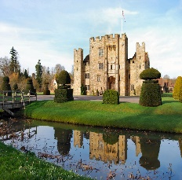  08.00 - Departure  18.00 – Arrival  Packed lunch provided  (by LTC for residential students, by families for homestay students)  Coaches arrive & depart  to / from LTC | with Social Team  Supervised
12.30 | Lunch
13.30-18.00 | New Students  Orientation Tour of Eastbourne | Others –  (limited spaces, sign up only)  with Social Team | Classes 13:45-15:30  (Semi-Intensive only)    (limited spaces, sign up only)  Roller Skating  (limited spaces, sign up only)  with Social Team | Trip to  Brighton and Sealife Centre      13.30 – Departure  18.00 – Arrival  Coaches arrive & depart  to / from LTC  Trip to  Battle Abbey  13.30 – Departure  18.00 – Arrival  Coaches arrive & depart  to / from LTC | Laser Quest  OR  Bowling  (limited spaces, sign up only)  with Social Team | Classes 13:45-15:30  (Semi-Intensive only)  with Social Team  Golf  limited spaces, sign up only)  Supervised
18.00 | Dinner at LTC |  |  |  |  |  | Dinner | Dinner
19.00-22.00 |  |  |  | (limited spaces, sign up only)  with Social Team |  | With Social Team

